Abigail Bembridge (2305624), Kaif Brown (2304843), Kadedra Mason (2304879)
Faculty of Engineering and Computing, University of Technology, Ja
CIT2004: Object Oriented Programming
Phillip Smith
November 30, 2024

Table of Contents
Object Oriented Analysis 3
UML Diagrams 5
Class Relationship Diagram 7

Object Oriented Analysis

Red Plate Licensing System (RPLS)
Nouns: System, Processing officer, Applicant, Ticketing Issuing and Offender Checking System (TIOCS), Application, Owner, Red plate license, Driver, Accident, Police record, Ticket, Outstanding tickets, Permit, Report, Tax Registration Number (TRN), Full name, Date of birth, Current address, Email address, Contact number, Number of tickets, Amount, Reason, Statement, Disqualification, Business days, Ticket Issue Date, Payment Due Date, Ticket Number, Offence Code, Offence Description, Fine Amount, Ticket Status Description, Court Date, Court Location, Total unpaid tickets, Total fine amount, Online payment, Past-due tickets, Time, Charges, Warrant, Police station
Verbs: Check, Create, Update, Delete, Reject, Indicate, Pay, Process, Apply, Ask, Ensure, Receive, Check, Issue, Provide, Search, Show, Reflect, Appear, Answer, Turn in, View

Object: Processing Officer
Methods: Check Status, Create Application, Update Application, Delete Application, Reject Application, Indicate Payment

Object: Tickets
Attributes: Ticket Number, Issue Date, Due date, Offence Code, Offence Description
Methods: Display

Object: Applicant
Attributes: Name, TRN, Date of Birth, Email, Contact Number, Status, Outstanding Tickets, Police Record Check, Driver qualification
Methods: Check Status, Create Application, Update Application, Delete Application, Reject Application

Object: Driver
Attributes: Drivers TRN, Driver’s Full Name, Driver's Date of Birth, Driver's Address, Driver's Contact Number
Methods: Make Online payment, check for past due tickets, View Tickets, Check for warrant

Object: Address
Attributes: Street, City, Parish
Methods: Display

Ticketing Issuing and Offender Checking System (TIOCS)
Nouns: JCF Officer, Offender, Ticket, Driver’s License Number, TRN, Vehicle License Plate Number, Offence Code, Offence Description, Fine Amount, Ticket Number, Ticket Issue Date, Driver’s Full Name, Driver’s Date of Birth, Driver’s Address, Driver’s Contact Number, Badge Number, Police Station, Outstanding Ticket, Parish, Offender Report, Convictions, 21-Day Stipulation, Gender
Verbs: Add, Check, Delete, Verify, View, Sort, Produce, Update, Assign, Identify, Search

Object: JCF Officer
Attributes: Badge Number, Full Name, Assigned Police Station
Methods: Add Tickets, View Ticket information, Check Status of driver, View All outstanding tickets

Object: Court Information
Attributes: Court Date, Court Location, Court Room
Methods: Display

Object: Fine
Attributes: Fine Code, Fine Amount
Method: Display

Object: Officer
Attributes: NONE
Methods: view tickets, Add tickets

UML Diagrams

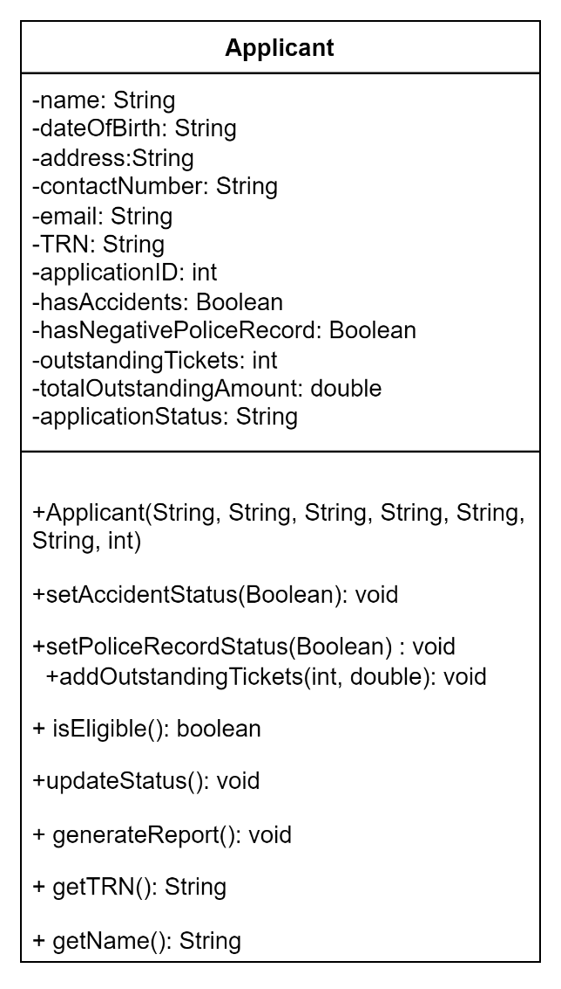
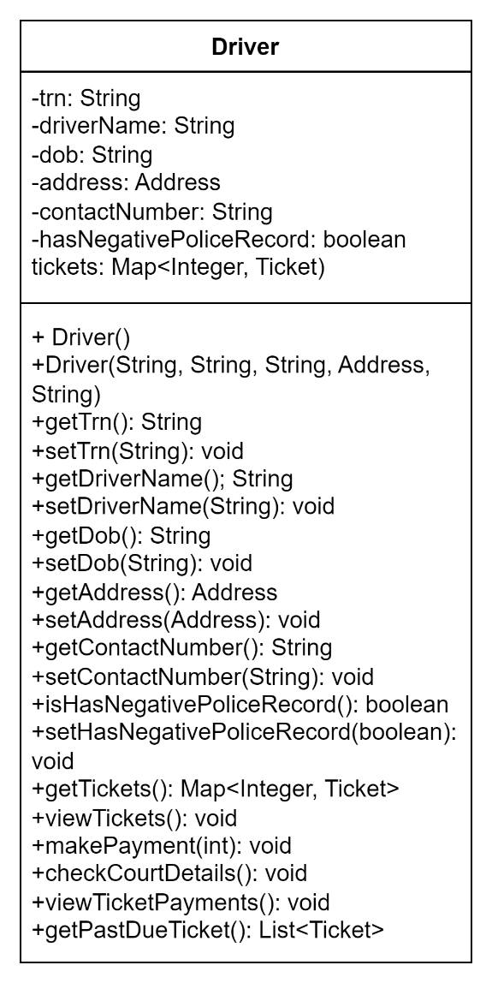

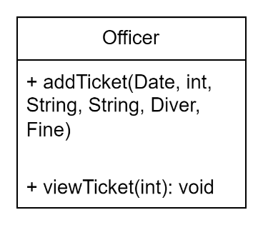
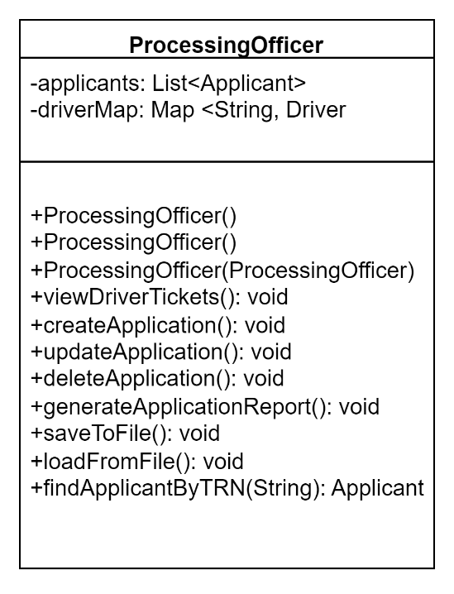
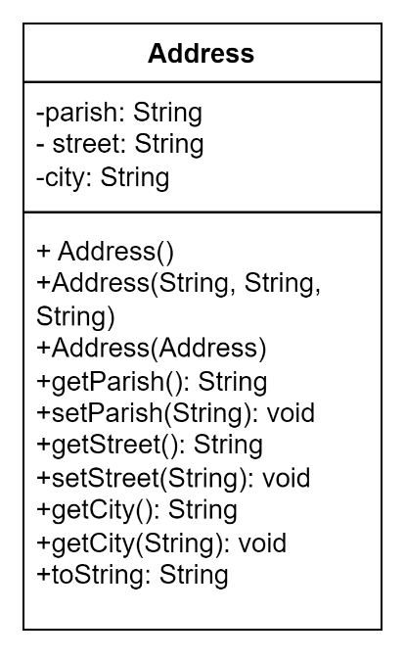

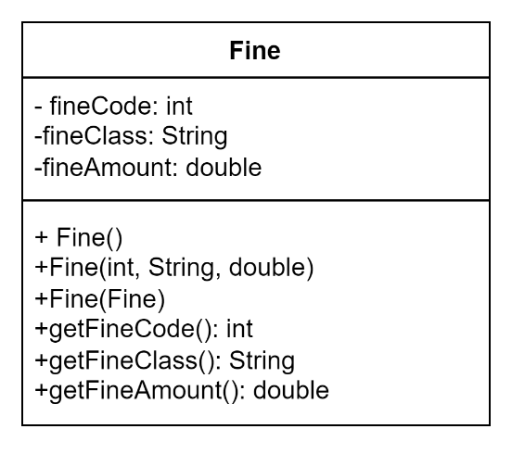
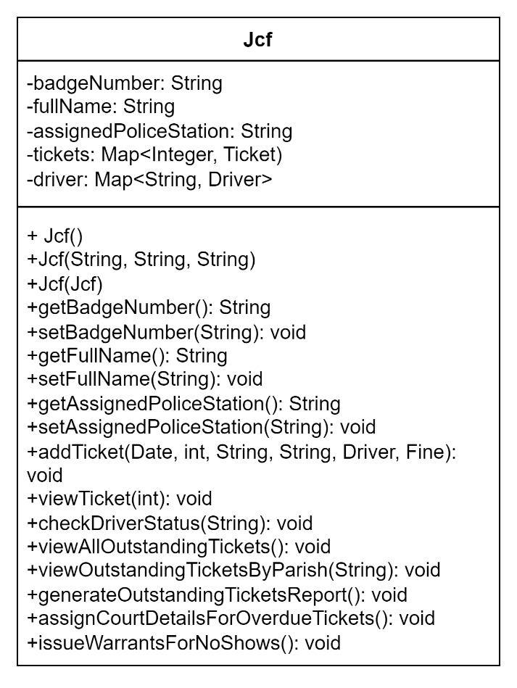

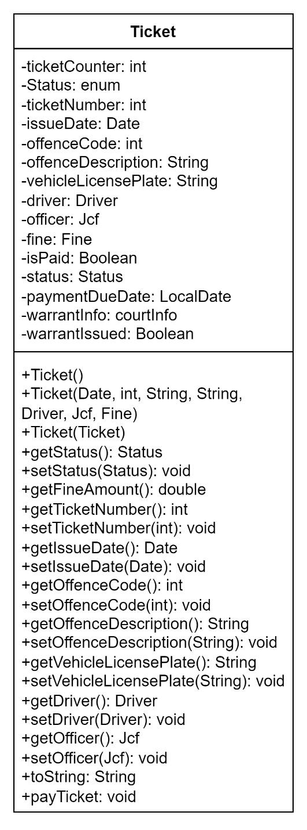

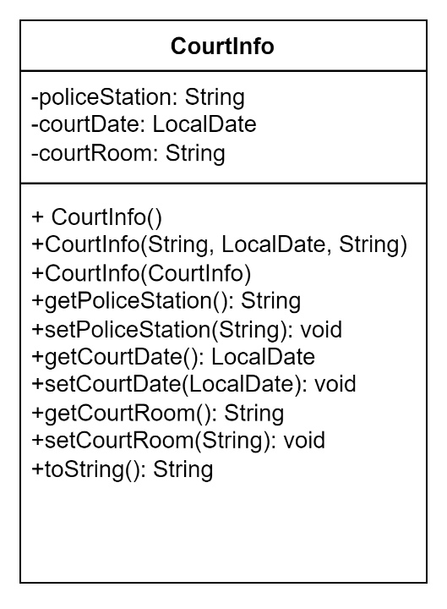

Class Relationship Diagram

